Oracle 12c 2 Nodes RAC environment on laptop version 1.0
2014.10.11
Shanoj Kumar

Short Introduction
It is my humble effort to help me like people to setup their own RAC environment on Laptop for practice. In second version I am planning to include 12c Dataguard and Pluggable Database.

2 Nodes Oracle 12c RAC with 3 IPs SCAN infrastructure
- Oracle Linux Server 6.4
- Oracle Virtual Box 4.2

You should have a laptop with:
- 6 GB of RAM
- 40G of free space disk space
  - 9GB - Software Staging
  - 29GB – 2 VMs + ASM disks
- Windows 64 bit
  - Windows 32 bit: You Oct run into memory related issues

References
www.oracle-base.com
- Oracle Database 11g Release 2 (11.2.0.3.0) RAC On Oracle Linux 6.3 Using VirtualBox
- Oracle Linux 6 Installation

About the author
Shanoj Kumar - Indian currently living in Chennai, TN
working for HCL Technologies.

Before you start

Software Components (I used on my testing the setup)

- Windows 7 64 bit
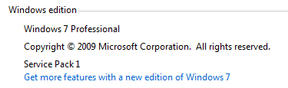
- Virtual Box
  - https://www.virtualbox.org/
  - 4.2.14 r86644
Note: I have updated to 4.2.16 version as of 2014 .07.05. It works ok.


- Pre-installed DualServer 6.94 (Local Windows DNS Server for SCAN)
  - http://dhcp-dns-server.sourceforge.net/
  - See “DualServer configuration” appendix for how to configure it for the needs of this implementation.
- Download Oracle software from eDelivery web site
  - Oracle Linux 6.4
    - E11882_01.zip =>unzip =>V37084-01.iso
    - http://edelivery.oracle.com/linux
  - Oracle Grid Infrastructure and Database 12c (12.1.0.1)
    - V38501-01_1of2.zip
    - V38501-01_2of2.zip
    - V38500-01_1of2.zip
    - V38500-01_2of2.zip
    - https://edelivery.oracle.com/

Network configuration
I have used the following network setup. Feel free to adjust to your needs:
- Public IPs 10.154.137.0/24
  - internal network only
  - visible and available to your laptop only even if it isn’t connected to any network
- Interconnect 10.154.138.0/24
  - private IPs available from RAC nodes only
- SCAN
  - Name =>scan-f1.shanojfun.com
  - IPs =>10.154.137.115/116/117
- Internet access from RAC nodes (e.g. access to Oracle public yum)
  - Just run "ifup eth2" (NAT interface) while connected to an internet

Change log

Remove 70-persistent-net.rules on second node
mv /etc/udev/rules.d/70-persistent-net.rules ~/

Install pre-install package with 12c version

time yum install -y oracle-rdbms-server-12cR1-preinstall

Implementation process
Main steps
- Setup VBOX
- Create one node
- Create shared ASM devices
- Clone node
- Install Grid Infrastructure
- Install Database Software
- Create Database
- Enjoy and experiment

Virtual Machine Setup

Setup VBOX
If you didn’t do it yet the installation part is straight forward. Just download the latest version from https://www.virtualbox.org/ and install (Next, Next, Next ...)

OVB(will use this abbreviation referencing to Oracle Virtual Box)
=> File Preferences => Network => Add host-only network =>
Edit => => IPv4 Address:
10.154.137.1
IPv4 Network Mask
255.255.255.0
OK => OK

Create one node

Node
OVB => Machine => New =>
ol6-12c-rac1
=> Linux => Oracle 64bit =>Memory Size
3072
=> Create a virtual hard drive now =>VDI => Dynamically allocated =>
F:\vbox\ol6-12c-rac_1\ol6-12c-rac1.vdi
30 GB
=> Create

Network setup
OVB =>ol6-12c-rac1 => Settings ... => Network =>
Adapter 1 => Host-only Adapter =>Enable Network Adapter
Adapter 2 =>Internal Network =>Enable Network Adapter
Adapter 3 =>NAT => Enable Network Adapter
OK

Notes:
- Adapter 1 => Host only Adapter - Allows to start and access the Cluster even if you are not connected to any networks
- Adapter 3 - Allows you to get access to the Internet from RAC nodes by starting eth2 adapter

Plug in CDROM
OVB => ol6-12c-rac1 => Settings ... => Storage =>Empty => =>
=>V37084-01.iso
OK

Install Linux
OVB => ol6-12c-rac1 => Machine =>Start

Install or upgrade an existing system
Skip => Next =>Next =>Next =>Next => Yes Discard Any Data =>
ol6r01.shanojfun.com
Configure Network =>

System eth0 => Connect Automatically => IPv4 Settings => Method => Manual => Add =>
Address =>
10.154.137.101
Netmask =>
255.255.255.0
Apply...
System eth1 => Connect Automatically => IPv4 Settings => Method => Manual => Add =>
Address =>
10.154.138.101
Netmask =>
255.255.255.0
Apply...

System eth2 => Leave default (DHCP, No Connect Automatically)
Close

Next=> Any time zone => Next=>< root password > =>Next

Use All Space =>Review and modify partitioning layout
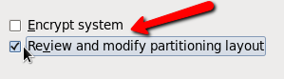
Next

lv_root => Delete
lv_swap =>4096
Free => Mount Point => “/” => File System Type =>ext3=> OK
/boot => File System Type => ext3 => OK

Result:
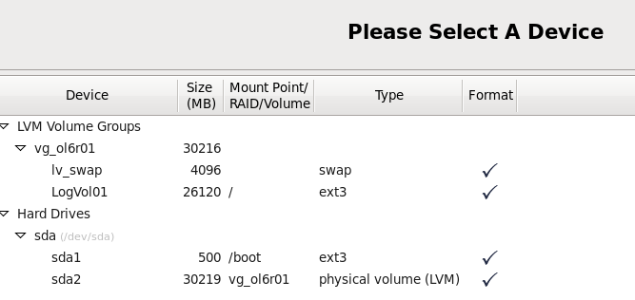

Next => =>Write changes to disk
Next =>(minimum) Basic Server => Next
(Timing Start 11:17 => Finish 11:25 => 8 mins) => Reboot

Linux post install configuration
putty root@10.154.137.101
echo 10.154.137.101 ol6r01ol6r01.shanojfun.com >>/etc/hosts
echo 10.154.137.102 ol6r02 ol6r02.shanojfun.com >>/etc/hosts
echo 10.154.138.101 ol6r01-priv ol6r01-priv.shanojfun.com >>/etc/hosts
echo 10.154.138.102 ol6r02-priv ol6r02-priv.shanojfun.com >>/etc/hosts
echo 10.154.137.103 ol6r01-vip ol6r01-vip.shanojfun.com >>/etc/hosts
echo 10.154.137.104 ol6r02-vip ol6r02-vip.shanojfun.com >>/etc/hosts
mv /etc/selinux/config /etc/selinux/config.orig
sed s/SELINUX=enforcing/SELINUX=disabled/g /etc/selinux/config.orig > /etc/selinux/config
service iptables stop
chkconfig iptables off
service ntpd stop
chkconfig ntpd off
mv /etc/ntp.conf /etc/ntp.conf.orig
ifup eth2

Oracle public yum setup
REF: http://public-yum.oracle.com/
OVB => ol6-12c-rac1 => Settings ... => Storage => Empty => =>=>V37084-01.iso
mount /dev/cdrom /media/
rpm -Uvf /media/Packages/wget-1.12-1.8.el6.x86_64.rpm

cd /etc/yum.repos.d
wget http://public-yum.oracle.com/public-yum-ol6.repo

RPMs update from yum
time yum install -yoracle-rdbms-server-12cR1-preinstall
yum install oracle-rdbms-server-11gR2-preinstall
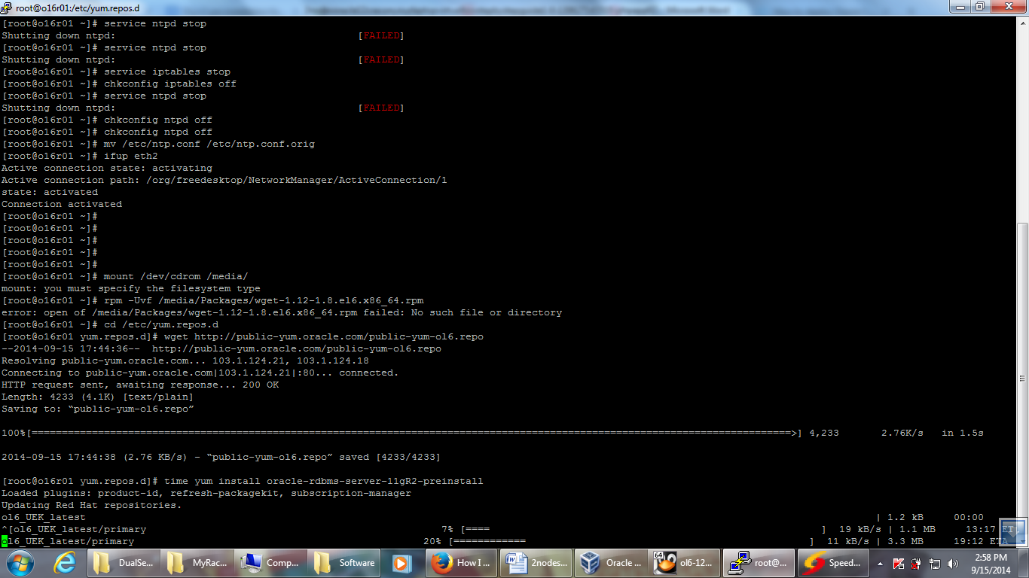

# time yum install -y oracle-rdbms-server-11gR2-preinstall # Used in the first guide’s versions
…
Install 21 Package(s)
…
Complete!

real 7m9.748s
...

time yum update-y
...
Install 5 Package(s)
Upgrade 117 Package(s)

Total download size: 199 M
...
Error Downloading Packages:
1:java-1.7.0-openjdk-1.7.0.25-2.3.10.3.0.1.el6_4.x86_64: failure: getPackage/java-1.7.0-openjdk-1.7.0.25-2.3.10.3.0.1.el6_4.x86_64.rpm from ol6_latest: [Errno 256] No more mirrors to try.
1:java-1.6.0-openjdk-1.6.0.0-1.61.1.11.11.el6_4.x86_64: failure: getPackage/java-1.6.0-openjdk-1.6.0.0-1.61.1.11.11.el6_4.x86_64.rpm from ol6_latest: [Errno 256] No more mirrors to try.

real 34m48.846s

time yum update –y
...
Install 5 Package(s)
Upgrade 117 Package(s)
...

Complete!

real 3m35.784s
user 2m37.210s
sys 0m28.499s
[root@ol6r01 yum.repos.d]#

time yum update -y
Loaded plugins: security
Setting up Update Process
No Packages marked for Update

real 0m1.170s
user 0m1.021s
sys 0m0.146s
[root@ol6r01 yum.repos.d]#

Install additional RPMs
time yum install -y tigervnc-server.x86_64 xclock mankernel-uek-develparted.x86_64unzip.x86_64 xterm lsof
Install 11 Package(s)

Total download size: 17 M
Installed size: 44 M
...
Complete!

real 10m2.364s
user 0m40.615s
sys 0m4.445s

-- Check current kernel version
[root@ol6r01 yum.repos.d]# uname -a
Linux ol6r01.shanojfun.com 2.6.39-400.17.1.el6uek.x86_64 #1 SMP Fri Feb 22 18:16:18 PST 2014 x86_64 x86_64 x86_64 GNU/Linux
[root@ol6r01 yum.repos.d]#

Configuring Shared storage
Stop OVB host ol6r01
init 0

-- Create 4 disks
OVB =>ol6-12c-rac1 => Settings ... => Storage => Controller SATA =>

Add Hard Drive =>
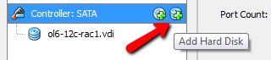
Create new disk =>
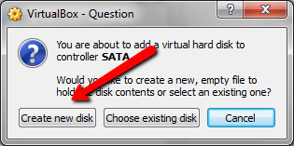

=>VDI =>Fixed Size (otherwise you will not be able to make it sharable)
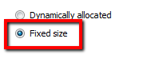
F:\vbox\ol6-12c-rac_1\asm1.vdi
5120 MB
=> Create
-- Create 3 more Disks
F:\vbox\ol6-12c-rac_1\asm2.vdi
5120 MB
F:\vbox\ol6-12c-rac_1\asm3.vdi
5120 MB
F:\vbox\ol6-12c-rac_1\asm4.vdi
5120 MB
OK

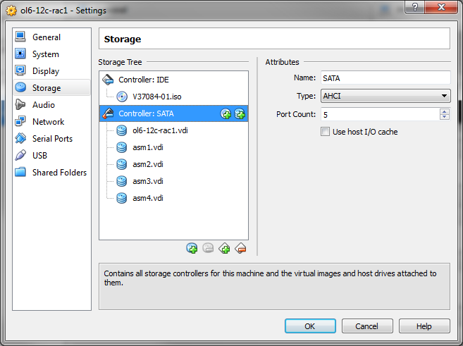

-- Make the HDDs shareable
OVB => File => Virtual Media Manager =>asm1/2/3/4.vdi => Modify => Shareable => Close

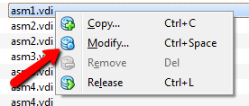

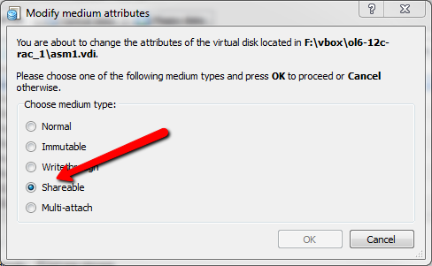

VBoxLinuxAdditions
Remove mounted CD ROM
OVB => ol6-12c-rac1 => Settings ... => Storage =>CDROM
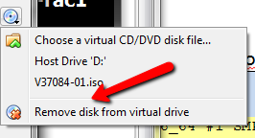

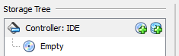

OVB => ol6-12c-rac1 => Machine => Start
-- Check if kernel version got updated (otherwise VBoxLinuxAdditions.runphase Oct fail)
putty root@10.154.137.101
[root@ol6r01 ~]# uname -a
Linux ol6r01.shanojfun.com 2.6.39-400.109.1.el6uek.x86_64 #1 SMP Tue Oct 7 23:21:51 PDT 2014 x86_64 x86_64 x86_64 GNU/Linux
[root@ol6r01 ~]#

OVB => Devices => Install Guest Additions …
mount /dev/cdrom /media/
sh /media/VBoxLinuxAdditions.run

NOTE: You Oct need to check what path is used for cdrom in your case and mount the right one "ls -l /dev/cdrom*"

[root@ol6r01 ~]# /media/VBoxLinuxAdditions.run
Verifying archive integrity... All good.
Uncompressing VirtualBox 4.2.12 Guest Additions for Linux............
VirtualBox Guest Additions installer
Removing installed version 4.2.12 of VirtualBox Guest Additions...
Copying additional installer modules ...
Installing additional modules ...
Removing existing VirtualBox non-DKMS kernel modules [ OK ]
Building the VirtualBox Guest Additions kernel modules
The headers for the current running kernel were not found. If the following
module compilation fails then this could be the reason.
The missing package can be probably installed with
yum install kernel-uek-devel-2.6.39-400.24.1.el6uek.x86_64

Building the main Guest Additions module [ OK ]
Building the shared folder support module [ OK ]
Building the OpenGL support module [ OK ]
Doing non-kernel setup of the Guest Additions [ OK ]
Starting the VirtualBox Guest Additions [ OK ]
Installing the Window System drivers [FAILED]
(Could not find the X.Org or XFree86 Window System.)
[root@ol6r01 ~]#
============================

NOTE: “Installing the Window System drivers [FAILED]” - could be ignored as we don’t run X Windows.

Configure persistence devices’ naming
[root@ol6r01 ~]# ls -l /dev/sd*
brw-rw---- 1 root disk 8, 0 Oct 21 16:54 /dev/sda
brw-rw---- 1 root disk 8, 1 Oct 21 16:54 /dev/sda1
brw-rw---- 1 root disk 8, 2 Oct 21 16:54 /dev/sda2
brw-rw---- 1 root disk 8, 16 Oct 21 16:54 /dev/sdb
brw-rw---- 1 root disk 8, 32 Oct 21 16:54 /dev/sdc
brw-rw---- 1 root disk 8, 48 Oct 21 16:54 /dev/sdd
brw-rw---- 1 root disk 8, 64 Oct 21 16:54 /dev/sde
[root@ol6r01 ~]#

fdisk /dev/sdb
fdisk /dev/sdc
fdisk /dev/sdd
fdisk /dev/sde
"n", "p", "1", "Return", "Return" and "w"
ls -l /dev/sd*

[root@ol6r01 ~]# ls -l /dev/sd*
brw-rw---- 1 root disk 8, 0 Oct 21 16:54 /dev/sda
brw-rw---- 1 root disk 8, 1 Oct 21 16:54 /dev/sda1
brw-rw---- 1 root disk 8, 2 Oct 21 16:54 /dev/sda2
brw-rw---- 1 root disk 8, 16 Oct 21 17:03 /dev/sdb
brw-rw---- 1 root disk 8, 17 Oct 21 17:03 /dev/sdb1
brw-rw---- 1 root disk 8, 32 Oct 21 17:03 /dev/sdc
brw-rw---- 1 root disk 8, 33 Oct 21 17:03 /dev/sdc1
brw-rw---- 1 root disk 8, 48 Oct 21 17:03 /dev/sdd
brw-rw---- 1 root disk 8, 49 Oct 21 17:03 /dev/sdd1
brw-rw---- 1 root disk 8, 64 Oct 21 17:04 /dev/sde
brw-rw---- 1 root disk 8, 65 Oct 21 17:04 /dev/sde1
[root@ol6r01 ~]#

Configure your UDEV rules
ls -l /etc/scsi_id.config

[root@ol6r01 ~]# ls -l /etc/scsi_id.config
ls: cannot access /etc/scsi_id.config: No such file or directory

echo "options=-g" >/etc/scsi_id.config

/sbin/scsi_id -g -u -d /dev/sdb ; /sbin/scsi_id -g -u -d /dev/sdc ; /sbin/scsi_id -g -u -d /dev/sdd ; /sbin/scsi_id -g -u -d /dev/sde

[root@ol6r01 ~]# /sbin/scsi_id -g -u -d /dev/sdb ; /sbin/scsi_id -g -u -d /dev/sdc ; /sbin/scsi_id -g -u -d /dev/sdd ; /sbin/scsi_id -g -u -d /dev/sde
1ATA_VBOX_HARDDISK_VB425c30d2-a5a6fd28
1ATA_VBOX_HARDDISK_VBf3f3b07b-fc36040a
1ATA_VBOX_HARDDISK_VBc1c2a35c-e0d538cc
1ATA_VBOX_HARDDISK_VB23d133e5-2420ccc8
[root@ol6r01 ~]#

cat >/etc/udev/rules.d/99-oracle-asmdevices.rules
KERNEL=="sd?1", BUS=="scsi", PROGRAM=="/sbin/scsi_id -g -u -d /dev/$parent", RESULT=="1ATA_VBOX_HARDDISK_VB425c30d2-a5a6fd28", NAME="asm-disk1", OWNER="oracle", GROUP="dba", MODE="0660"
KERNEL=="sd?1", BUS=="scsi", PROGRAM=="/sbin/scsi_id -g -u -d /dev/$parent", RESULT=="1ATA_VBOX_HARDDISK_VBf3f3b07b-fc36040a", NAME="asm-disk2", OWNER="oracle", GROUP="dba", MODE="0660"
KERNEL=="sd?1", BUS=="scsi", PROGRAM=="/sbin/scsi_id -g -u -d /dev/$parent", RESULT=="1ATA_VBOX_HARDDISK_VBc1c2a35c-e0d538cc", NAME="asm-disk3", OWNER="oracle", GROUP="dba", MODE="0660"
KERNEL=="sd?1", BUS=="scsi", PROGRAM=="/sbin/scsi_id -g -u -d /dev/$parent", RESULT=="1ATA_VBOX_HARDDISK_VB23d133e5-2420ccc8", NAME="asm-disk4", OWNER="oracle", GROUP="dba", MODE="0660"
Note: I have restarted the VM. But the following command should do.
/sbin/partprobe/dev/sdb1 /dev/sdc1 /dev/sdd1 /dev/sde1

/sbin/udevadm test /block/sdb/sdb1
/sbin/udevadm control --reload-rules
/sbin/start_udev
ls -al /dev/asm*

[root@ol6r01 ~]# ls -al /dev/asm*
brw-rw---- 1 oracle dba 8, 17 Oct 21 17:22 /dev/asm-disk1
brw-rw---- 1 oracle dba 8, 33 Oct 21 17:22 /dev/asm-disk2
brw-rw---- 1 oracle dba 8, 49 Oct 21 17:22 /dev/asm-disk3
brw-rw---- 1 oracle dba 8, 65 Oct 21 17:22 /dev/asm-disk4

DNC Server configuration
Pointto the DualServer IP (see “DualServer configuration”)
echo "search shanojfun.com"> /etc/resolv.conf
echo "nameserver 10.154.137.1" >> /etc/resolv.conf

Test
[root@ol6r01 ~]# dig scan-f1.shanojfun.com

; <<>> DiG 9.8.2rc1-RedHat-9.8.2-0.17.rc1.0.2.el6_4.4 <<>> scan-f1.shanojfun.com
;; global options: +cmd
;; Got answer:
;; ->>HEADER<<- opcode: QUERY, status: NOERROR, id: 57915
;; flags: qr rd ra; QUERY: 1, ANSWER: 3, AUTHORITY: 0, ADDITIONAL: 0

;; QUESTION SECTION:
;scan-f1.shanojfun.com. IN A

;; ANSWER SECTION:
scan-f1.shanojfun.com. 36000 IN A 10.154.137.115
scan-f1.shanojfun.com. 36000 IN A 10.154.137.116
scan-f1.shanojfun.com. 36000 IN A 10.154.137.117

;; Query time: 5 msec
;; SERVER: 10.154.137.1#53(10.154.137.1)
;; WHEN: Wed Jun 26 14:25:47 2014
;; MSG SIZE rcvd: 146

[root@ol6r01 ~]#

Change oracle OS user password
You will need this password later on during the grid infrastructure installation
passwd oracle

Create /u01/app directory
mkdir -p /u01/app
chown oracle:dba /u01/app

Clone the VM
init 0

Copy System HDD
OVB => File => Virtual Media Manager =>F:\vbox\ol6-12c-rac_1\ol6-12c-rac1.vdi => Copy =>
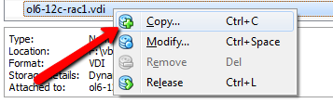
Next => Next => => Next
F:\vbox\ol6-12c-rac_1\ol6-12c-rac2.vdi
=> Close

Create second node

Node
OVB => Machine => New =>
ol6-12c-rac2
Linux => Oracle 64bit =>
3072
Use an existing virtual hard drive file =>
F:\vbox\ol6-12c-rac_1\ol6-12c-rac2.vdi
Create

Network setup
OVB =>ol6-12c-rac1 => Settings ... => Network =>
Adapter 1 => Host-only Adapter => Enable Network Adapter
Adapter 2 =>Internal Network => Enable Network Adapter
Adapter 3 =>NAT => Enable Network Adapter
OK

Add Shared devices
OVB => ol6-12c-rac2 => Settings ... => Storage => Controller SATA => Add Hard Disk => Chose existing disk =>F:\vbox\ol6-12c-rac_1\asm1.vdi
Repeat F:\vbox\ol6-12c-rac_1\asm2.vdi
Repeat F:\vbox\ol6-12c-rac_1\asm3.vdi
Repeat F:\vbox\ol6-12c-rac_1\asm4.vdi

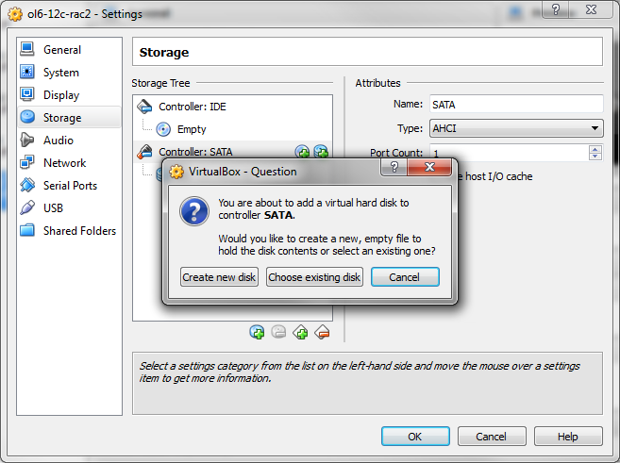

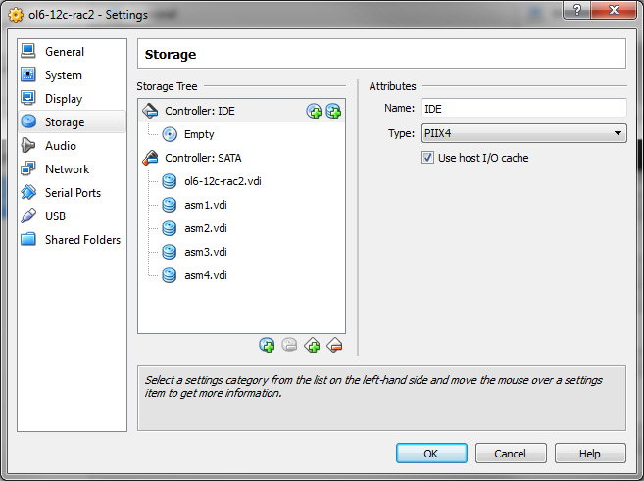

Start second node
OVB => ol6-12c-rac2 => Machine => Start

Adjust network setup
NOTE: from OVB VM console
vi /etc/sysconfig/network
HOSTNAME=ol6r02.shanojfun.com

ifconfig -a | grep eth

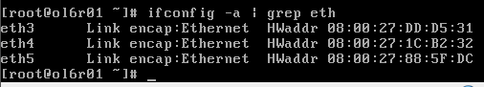
Note HWaddr

vi /etc/sysconfig/network-scripts/ifcfg-eth0
HWADDR=08:00:27:34:6C:04
IPADDR=10.154.137.102
# Delete =>UUID entry
vi /etc/sysconfig/network-scripts/ifcfg-eth1
HWADDR=08:00:27:77:1A:03
IPADDR=10.154.138.102
# Delete =>UUID entry
vi /etc/sysconfig/network-scripts/ifcfg-eth2
HWADDR=08:00:27:8B:7D:8B
# Delete =>UUID entry
mv /etc/udev/rules.d/70-persistent-net.rules ~/70-persistent-net.rules.orig
reboot

Start first node
OVB => ol6-12c-rac1 => Machine => Start
putty root@10.154.137.101
putty root@10.154.137.102

Test network from both nodes
ping -c 3 ol6r02
ping -c 3 ol6r02-priv
ping -c 3 ol6r01
ping -c 3 ol6r01-priv
Check UDEV devices from both nodes
ls -al /dev/asm*

[root@ol6r01 ~]# ls -al /dev/asm*
brw-rw---- 1 oracle dba 8, 17 Oct 21 21:27 /dev/asm-disk1
brw-rw---- 1 oracle dba 8, 33 Oct 21 21:27 /dev/asm-disk2
brw-rw---- 1 oracle dba 8, 49 Oct 21 21:27 /dev/asm-disk3
brw-rw---- 1 oracle dba 8, 65 Oct 21 21:27 /dev/asm-disk4

Create a backup of both nodes
Stop both nodes
init 0
OVB => ol6-12c-rac1 => snapshots => Take Snapshot => “OS ready 1”
OVB => ol6-12c-rac2 => snapshots => Take Snapshot => “OS ready 1”



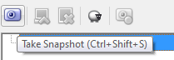

Installing Oracle software

Installing Grid Infrastructure

Configure VBOX shred folder
NOTE: C:\Downloads\12c - folder with Oracle installation files (archives)

OVB => ol6-12c-rac1 => Settings ... => Shared Folder => Add Shared Folder =>Folder Path =>C:\Downloads\12c
=>Folder Name =>12c =>Auto-mount =>Ok => Ok

OVB => ol6-12c-rac2 => Settings ... => Shared Folder => Add Shared Folder => Folder Path =>C:\Downloads\12c
=> Folder Name =>12c=> Auto-mount =>Ok => Ok

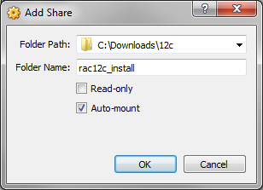

OVB => ol6-12c-rac1 => Machine => Start
OVB => ol6-12c-rac2 => Machine => Start
NOTE: The download folder is mounted automagically to /media/sf_12c/
putty root@10.154.137.101
cd /media/sf_12c/
time unzip -o V38500-01_1of2.zip; time unzip -o V38500-01_2of2.zip; time unzip -o V38501-01_1of2.zip;time unzip -o V38501-01_2of2.zip; date
real 1m43.338s
real 1m26.440s
real 3m6.112s
real 0m12.735s

rpm -Uvh /media/sf_12c/grid/rpm/cvuqdisk*.rpm
putty root@10.154.137.102
rpm -Uvh /u01/sw/rac_inst/grid/rpm/cvuqdisk*

Check DNS setup
From both hosts
REF: “DNC Server configuration”
[root@ol6r01 sf_12c]# nslookup scan-f1.shanojfun.com
Server: 10.154.137.1
Address: 10.154.137.1#53

Non-authoritative answer:
Name: scan-f1.shanojfun.com
Address: 10.154.137.115
Name: scan-f1.shanojfun.com
Address: 10.154.137.116
Name: scan-f1.shanojfun.com
Address: 10.154.137.117

[root@ol6r01 sf_12c]#

Start VNC and Install Grid
NOTE: You Oct want to make another snapshot at this stage “OS ready 3”
putty root@10.154.137.101
putty root@10.154.137.102
# both nodes
usermod -G oinstall,vboxsf oracle
# node 1
su - oracle
vncserver :1
export DISPLAY=:1

/media/sf_12c/grid/runInstaller

vncviewer =>10.154.137.101:1

Install GUI

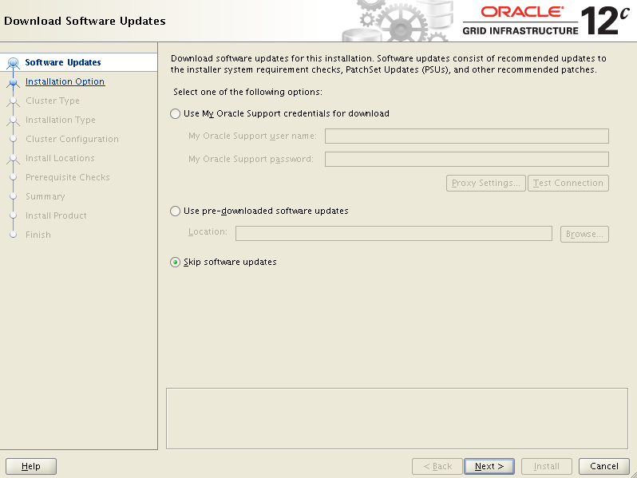

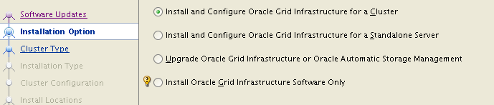

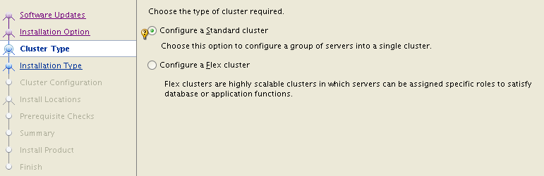

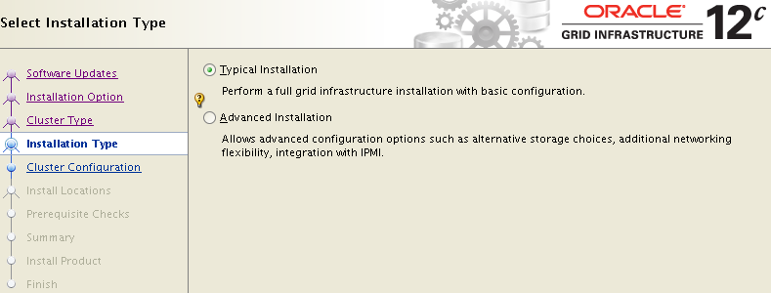

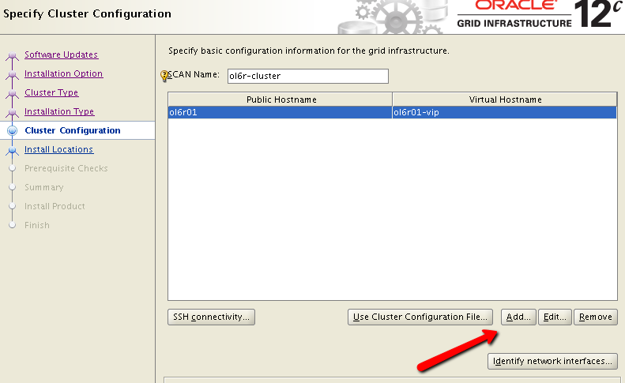

ol6r02
ol6r02-vip
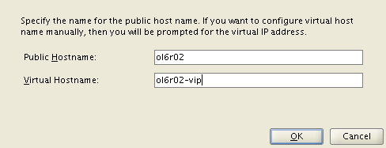

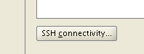

Setup
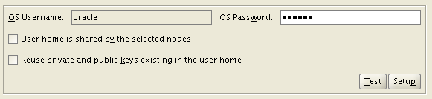

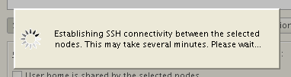

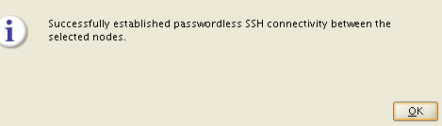

scan-f1.shanojfun.com
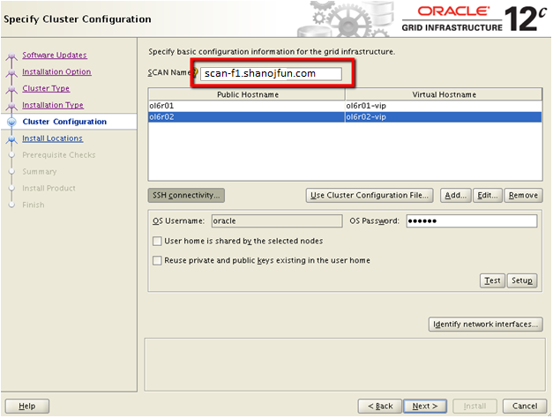

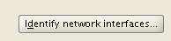

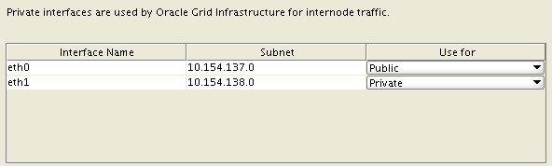

Next

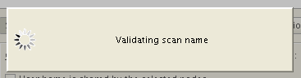

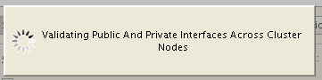

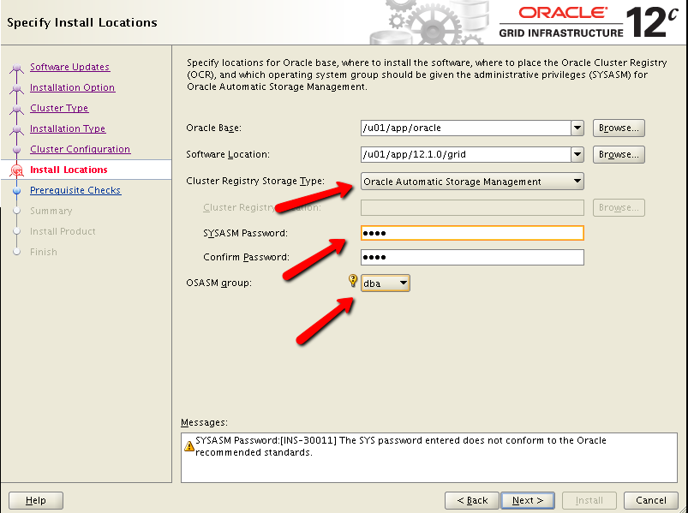

oracle1

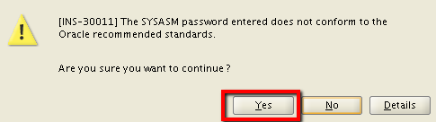



/dev/asm*

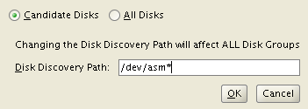

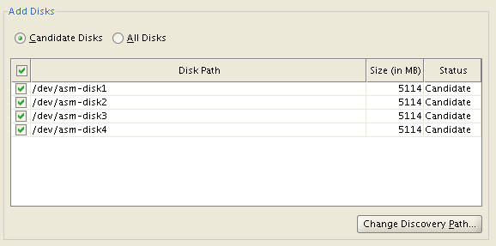

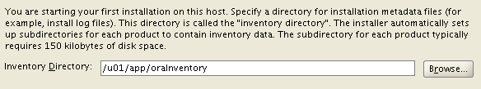

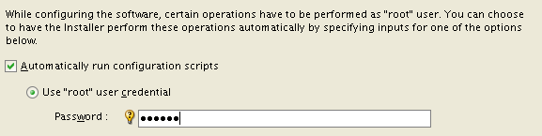

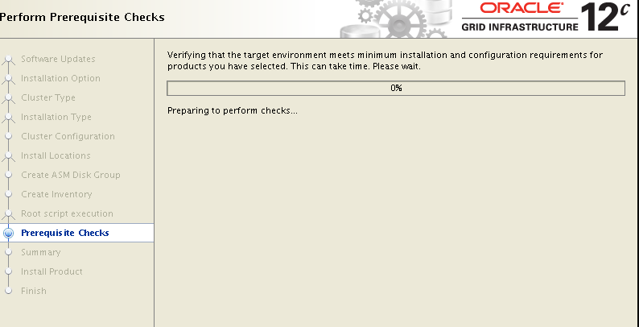

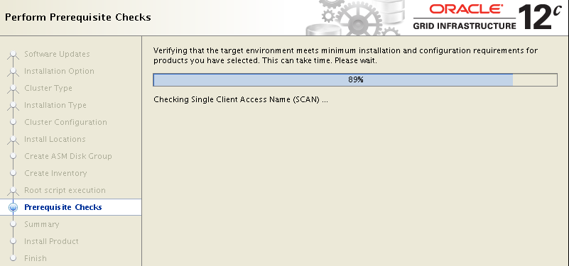

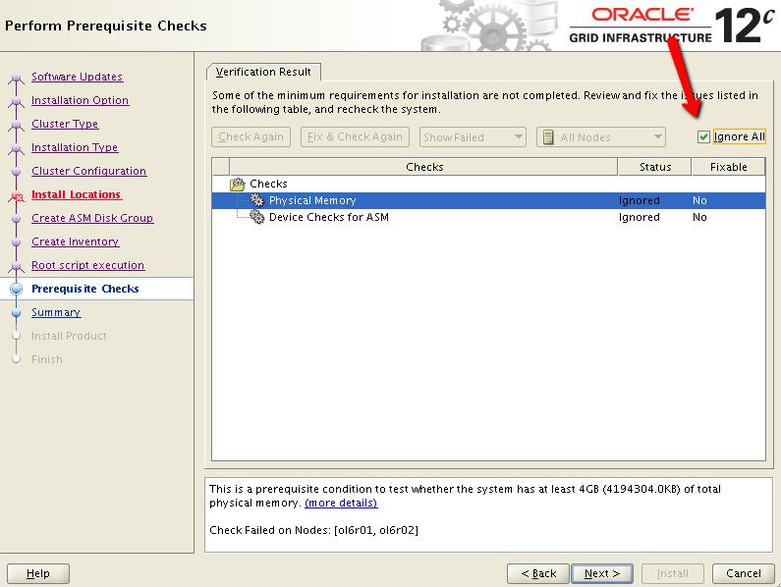

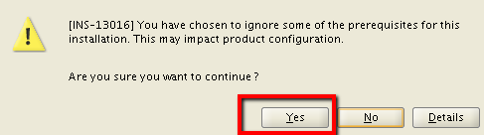



~/12crac_r01.rsp

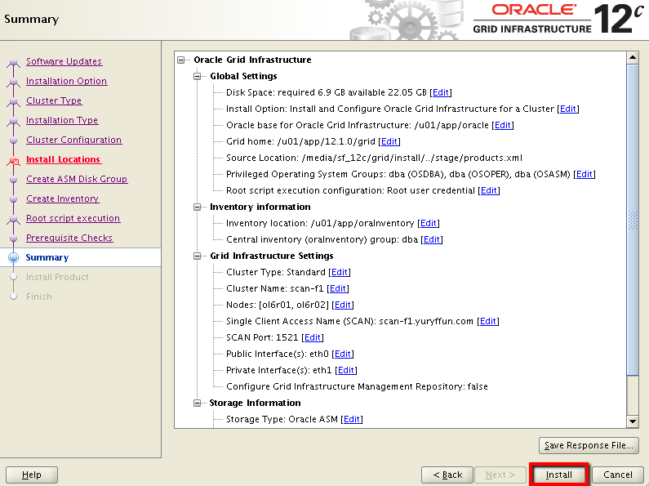

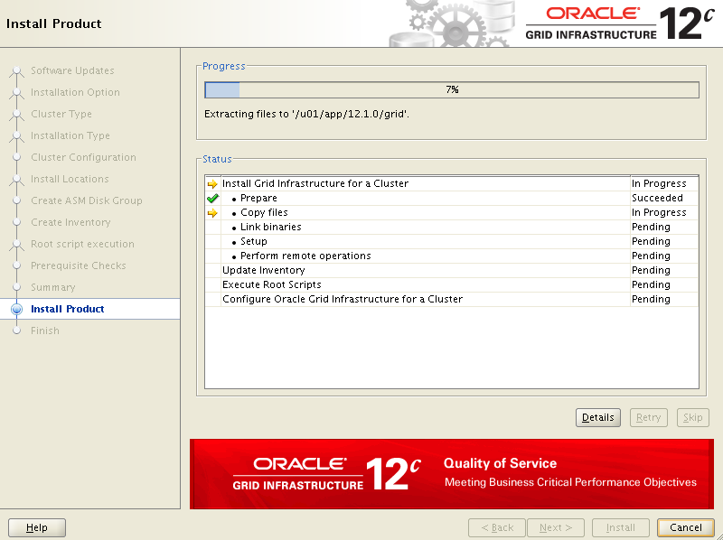

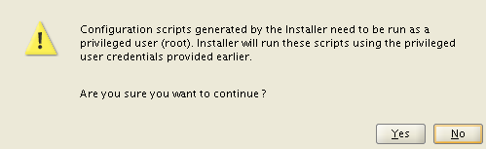

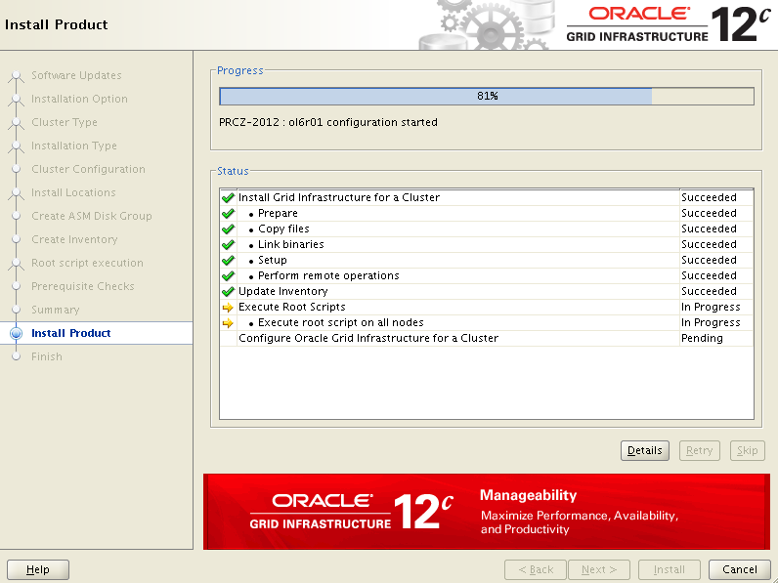

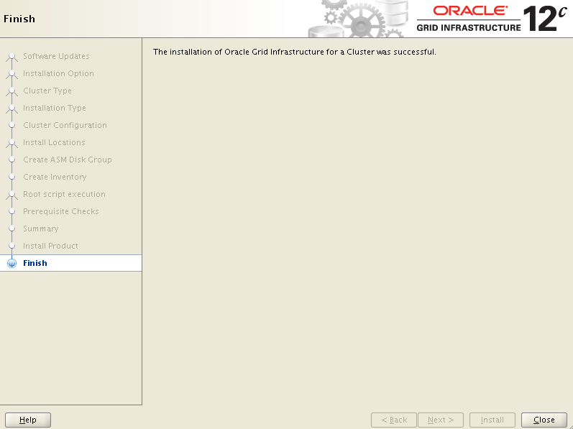

putty oracle@10.154.137.101
ORAENV_ASK=NO; ORACLE_SID=+ASM1; . oraenv
[oracle@ol6r01 ~]$ crsctl stat res -t
--------------------------------------------------------------------------------
Name Target State Server State details
--------------------------------------------------------------------------------
Local Resources
--------------------------------------------------------------------------------
ora.DATA.dg
ONLINE ONLINE ol6r01 STABLE
ONLINE ONLINE ol6r02 STABLE
ora.LISTENER.lsnr
ONLINE ONLINE ol6r01 STABLE
ONLINE ONLINE ol6r02 STABLE
ora.asm
ONLINE ONLINE ol6r01 Started,STABLE
ONLINE ONLINE ol6r02 Started,STABLE
ora.net1.network
ONLINE ONLINE ol6r01 STABLE
ONLINE ONLINE ol6r02 STABLE
ora.ons
ONLINE ONLINE ol6r01 STABLE
ONLINE ONLINE ol6r02 STABLE
--------------------------------------------------------------------------------
Cluster Resources
--------------------------------------------------------------------------------
ora.LISTENER_SCAN1.lsnr
1 ONLINE ONLINE ol6r02 STABLE
ora.LISTENER_SCAN2.lsnr
1 ONLINE ONLINE ol6r01 STABLE
ora.LISTENER_SCAN3.lsnr
1 ONLINE ONLINE ol6r01 STABLE
ora.cvu
1 ONLINE ONLINE ol6r01 STABLE
ora.oc4j
1 OFFLINE OFFLINE STABLE
ora.ol6r01.vip
1 ONLINE ONLINE ol6r01 STABLE
ora.ol6r02.vip
1 ONLINE ONLINE ol6r02 STABLE
ora.scan1.vip
1 ONLINE ONLINE ol6r02 STABLE
ora.scan2.vip
1 ONLINE ONLINE ol6r01 STABLE
ora.scan3.vip
1 ONLINE ONLINE ol6r01 STABLE
--------------------------------------------------------------------------------
[oracle@ol6r01 ~]$

Installing Oracle DB Software
putty oracle@10.154.137.101
export DISPLAY=:1
/media/sf_12c/database/runInstaller
vncviewer => 10.154.137.101:1


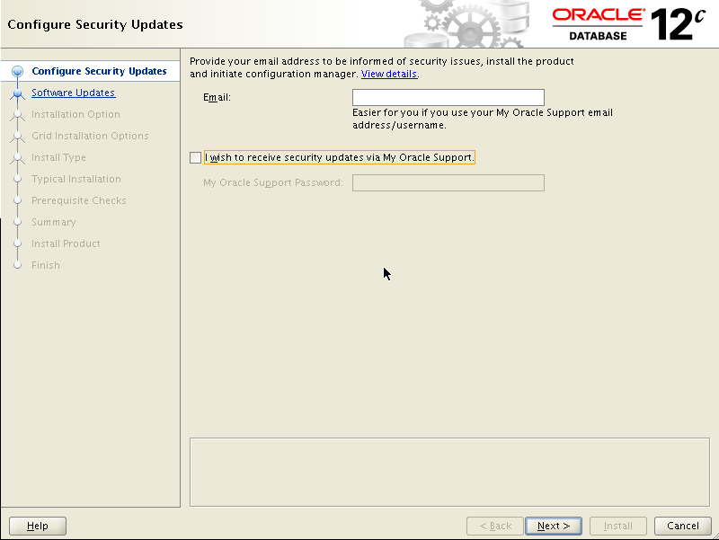

Untick
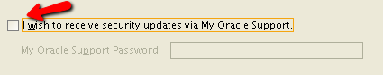

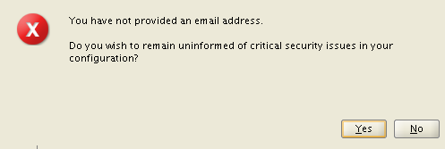

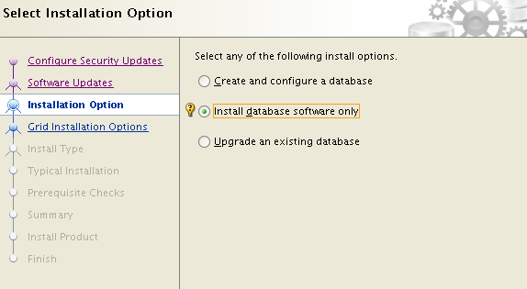

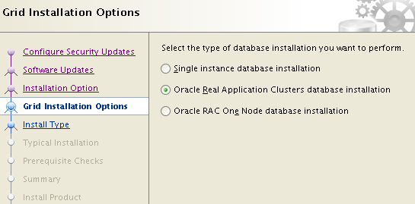

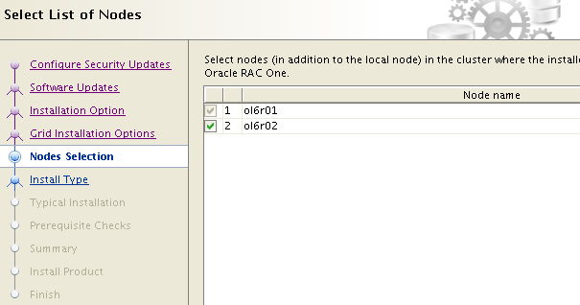



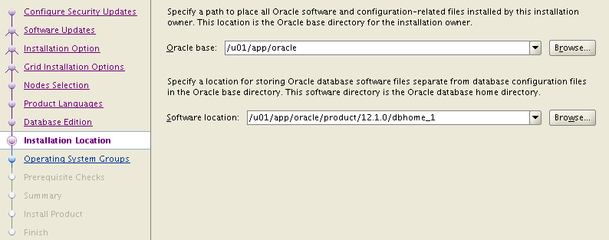

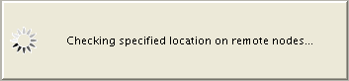

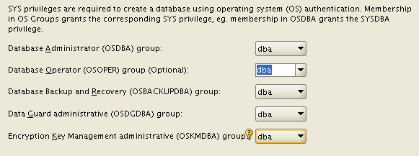

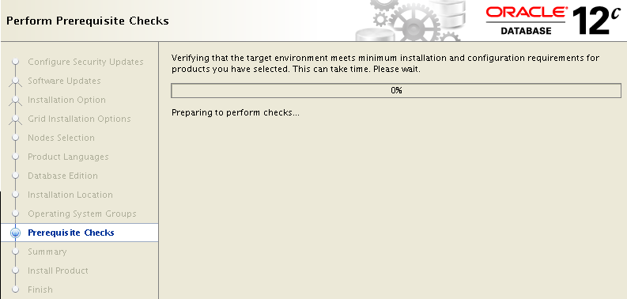

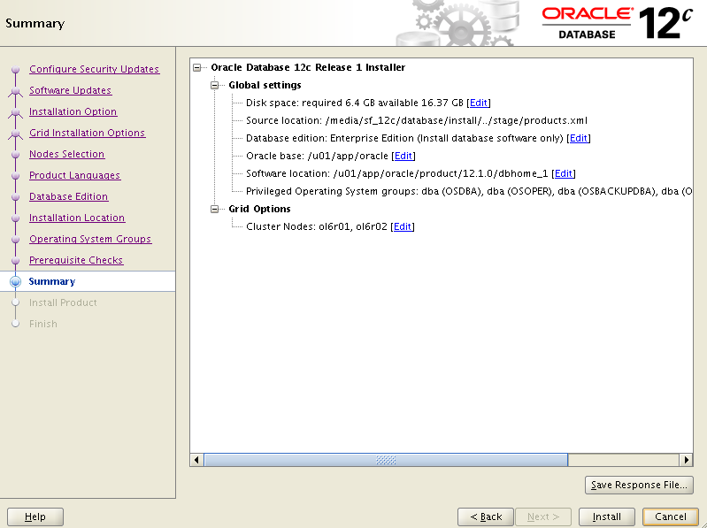

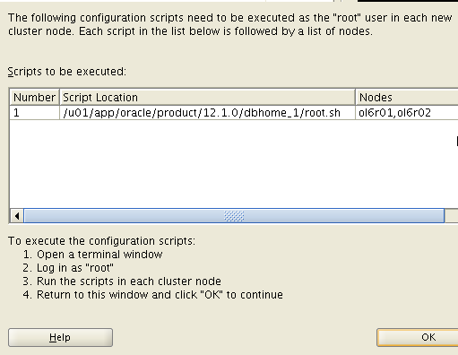

[root@ol6r01 sf_12c]# /u01/app/oracle/product/12.1.0/dbhome_1/root.sh
Performing root user operation for Oracle 12c

The following environment variables are set as:
ORACLE_OWNER= oracle
ORACLE_HOME= /u01/app/oracle/product/12.1.0/dbhome_1

Enter the full pathname of the local bin directory: [/usr/local/bin]:
The contents of "dbhome" have not changed. No need to overwrite.
The contents of "oraenv" have not changed. No need to overwrite.
The contents of "coraenv" have not changed. No need to overwrite.

Entries will be added to the /etc/oratab file as needed by
Database Configuration Assistant when a database is created
Finished running generic part of root script.
Now product-specific root actions will be performed.
[root@ol6r01 sf_12c]#

[root@ol6r02 sf_12c]# /u01/app/oracle/product/12.1.0/dbhome_1/root.sh
Performing root user operation for Oracle 12c

The following environment variables are set as:
ORACLE_OWNER= oracle
ORACLE_HOME= /u01/app/oracle/product/12.1.0/dbhome_1

Enter the full pathname of the local bin directory: [/usr/local/bin]:
The contents of "dbhome" have not changed. No need to overwrite.
The contents of "oraenv" have not changed. No need to overwrite.
The contents of "coraenv" have not changed. No need to overwrite.

Entries will be added to the /etc/oratab file as needed by
Database Configuration Assistant when a database is created
Finished running generic part of root script.
Now product-specific root actions will be performed.
[root@ol6r02 sf_12c]#



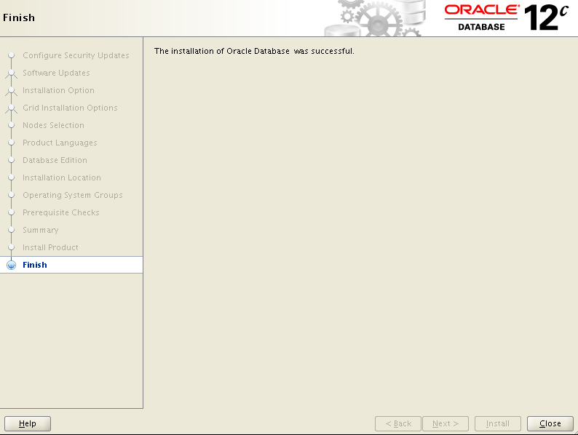

Creating Database
putty oracle@10.154.137.101
export DISPLAY=:1
/u01/app/oracle/product/12.1.0/dbhome_1/bin/dbca
vncviewer => 10.154.137.101:1


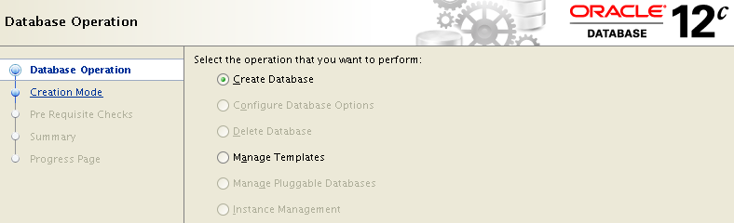

CAT.shanojfun.com
PAT

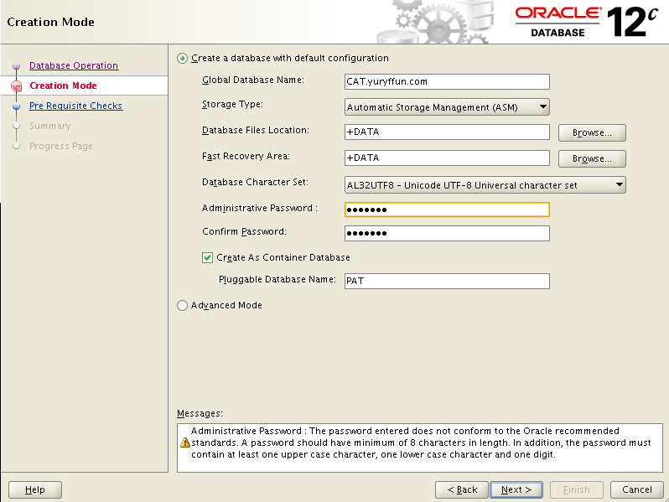

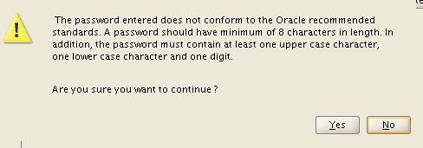

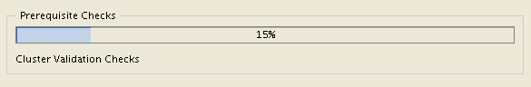

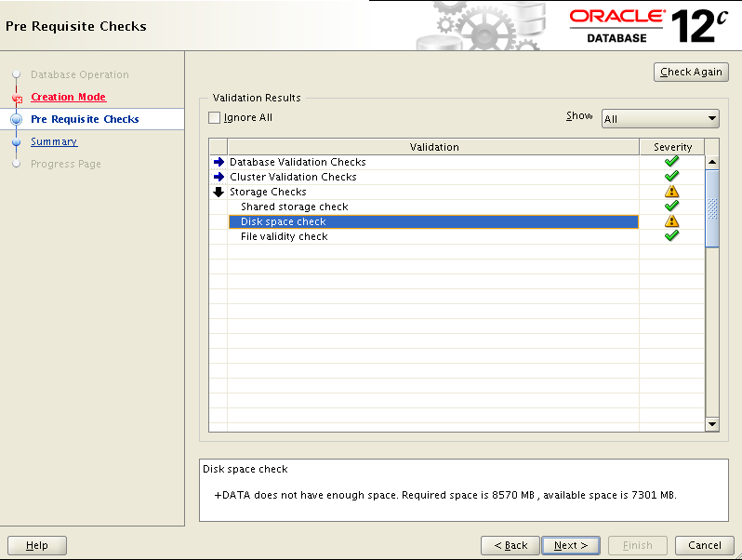

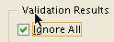

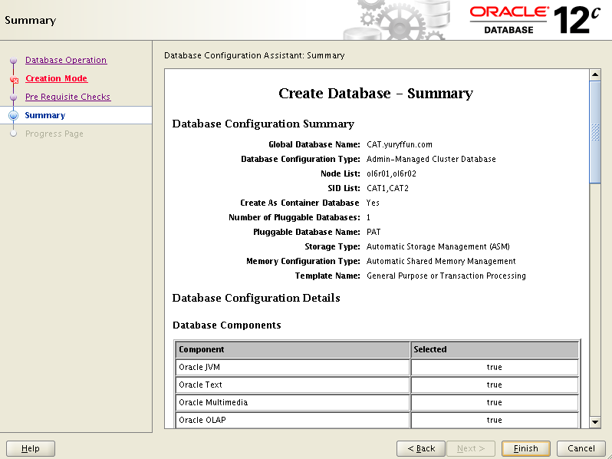

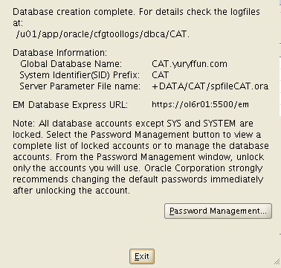

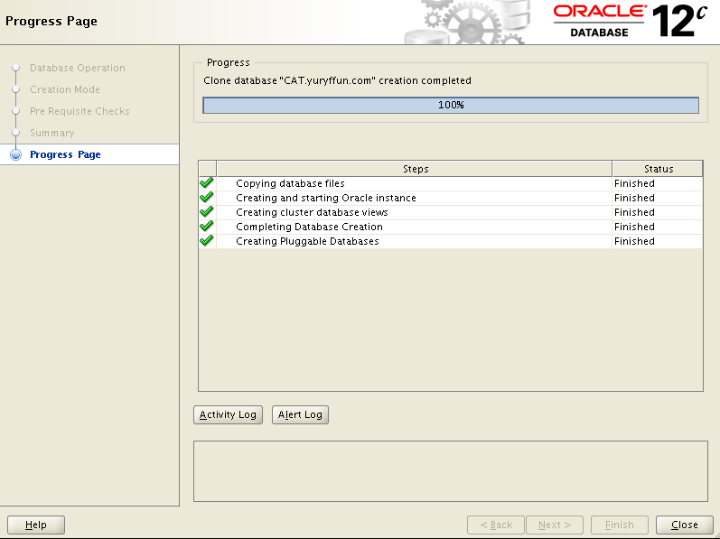

Connecting to the database
putty oracle@10.154.137.101
echo "CAT1:/u01/app/oracle/product/12.1.0/dbhome_1:N:" >> /etc/oratab
ORAENV_ASK=NO; ORACLE_SID=CAT1; . oraenv
sqlplus / as sysdba
[oracle@ol6r01 ~]$ sqlplus / as sysdba

SQL*Plus: Release 12.1.0.1.0 Production on Fri Jun 28 02:11:02 2014

Copyright (c) 1982, 2014 , Oracle. All rights reserved.

Connected to:
Oracle Database 12c Enterprise Edition Release 12.1.0.1.0 - 64bit Production
With the Partitioning, Real Application Clusters, Automatic Storage Management, OLAP,
Advanced Analytics and Real Application Testing options

SQL> select banner from v$version;

BANNER
--------------------------------------------------------------------------------
Oracle Database 12c Enterprise Edition Release 12.1.0.1.0 - 64bit Production
PL/SQL Release 12.1.0.1.0 - Production
CORE 12.1.0.1.0 Production
TNS for Linux: Version 12.1.0.1.0 - Production
NLSRTL Version 12.1.0.1.0 - Production

SQL> select INSTANCE_NAME, HOST_NAME from gv$instance;

INSTANCE_NAME HOST_NAME
---------------- ----------------------------------------------------------------
CAT1 ol6r01.shanojfun.com
CAT2 ol6r02.shanojfun.com

SQL>

Appendixes:

DualServer configuration (do before installing oracle)

Overview
The following is a short tasks overview that you need to accomplish to setup you DualServer to serve a local DNS service for SCAN component.
- Download and install “as administrator” DualServer on your windows workstation (http://dhcp-dns-server.sourceforge.net/)
- Make a backup copy of the DualServer.ini file and adjust the parameters mentioned in the “DualServer.ini” section below
- Restart the “Dual DHCP DNS Service” windows service
- Add a Windows firewall rule (see “Windows Local Firewall setup” section).
- Test the local DNS setup

DualServer.ini
Make a backup copy before adjusting the parameter file. I have highlighted the sections in yellow below to indicate what parameter you need to change.
notepad [installation path]\DualServer\DualServer.ini
# in my case "notepad C:\prog\DualServer\DualServer\DualServer.ini"

[SERVICES]
DNS
;DHCP
...
[LISTEN_ON]
10.154.137.1
# 127.0.0.1
...
[DNS_ALLOWED_HOSTS]
1.0.0.1-255.255.255.254
...
[DOMAIN_NAME]
...
shanojfun.com
...
[DNS_HOSTS]
...
scan-f1=10.154.137.115
scan-f1=10.154.137.116
scan-f1= 10.154.137.117
ol6r01=10.154.137.111
ol6r01.shanojfun.com=10.154.137.111
ol6r02= 10.154.137.112
ol6r02.shanojfun.com= 10.154.137.112
ol6r01-vip= 10.154.137.113
ol6r01-vip.shanojfun.com= 10.154.137.113
ol6r02-vip= 10.154.137.114
ol6r02-vip.shanojfun.com= 10.154.137.114

Restart “Dual DHCP DNS Service”
Windows => Search Program => Services => (Right click, Run as Administrator) 
Stop and Start the “Dual DHCP DNS Service” service
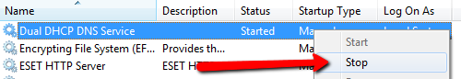

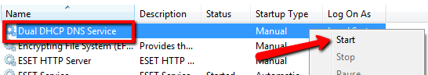

Windows Local Firewall setup
Windows => Search Program => Firewall => (Right click, Run as Administrator)
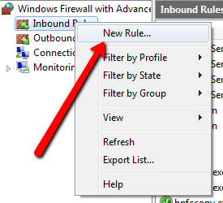

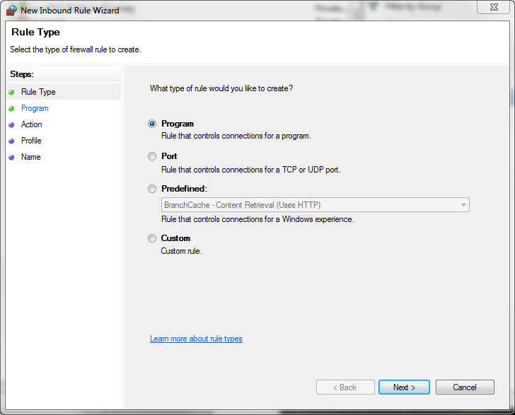

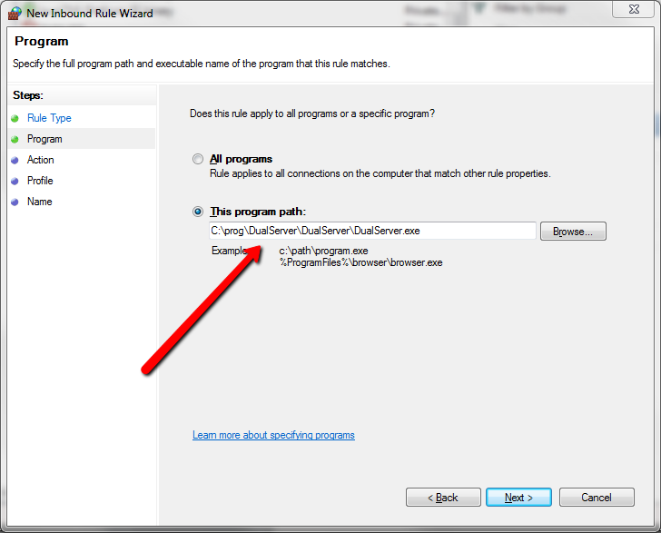

Next => Next

RAC12c_DNS

Optionally you can add Protocol/Port and Scope (see below)
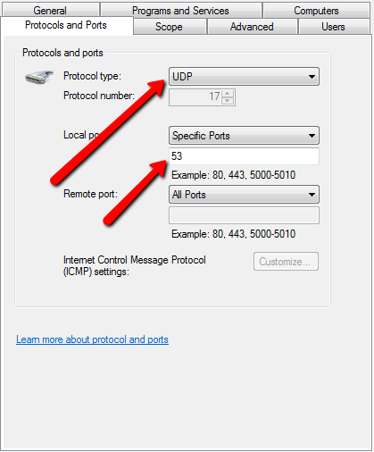
53
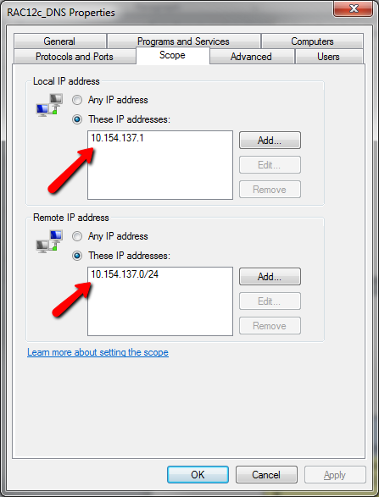
10.154.137.1
10.154.137.0/24

Test setup
From your workstation
cmd
C:\Users\velikanov>nslookup
Default Server: home.gateway.home.gateway
Address: 192.168.1.254

> server 10.154.137.1
Default Server: [10.154.137.1]
Address: 10.154.137.1

> scan-f1.shanojfun.com
Server: [10.154.137.1]
Address: 10.154.137.1

Non-authoritative answer:
Name: scan-f1.shanojfun.com
Addresses: 10.154.137.115
10.154.137.116
10.154.137.117

>

Cleaning up asm devices
Just in case you would like to repeat unsuccessful install you Oct want to clean ASM devices as Oracle will not allow you to use existing devices.
dd if=/dev/zero bs=8k count=1280 of=/dev/asm-disk1
dd if=/dev/zero bs=8k count=1280 of=/dev/asm-disk2
dd if=/dev/zero bs=8k count=1280 of=/dev/asm-disk3
dd if=/dev/zero bs=8k count=1280 of=/dev/asm-disk4

Network adjustments after VBOX Upgrade
I just upgraded Virtual Box from 4.2.14 to 4.2.16. This is that I had to do to make the setup work.
Note: You Oct just skip Remove/Add part and jump to reconfiguration. Let me know what way worked for you.

OVB => File => Preferences => Network => Remove
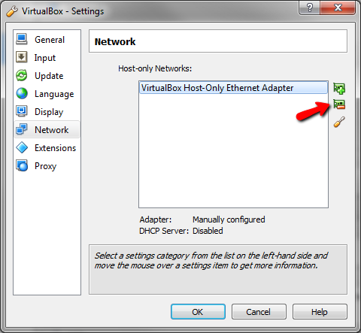
OVB => File => Preferences => Network => Add

OVB => File => Preferences => Network => Edit
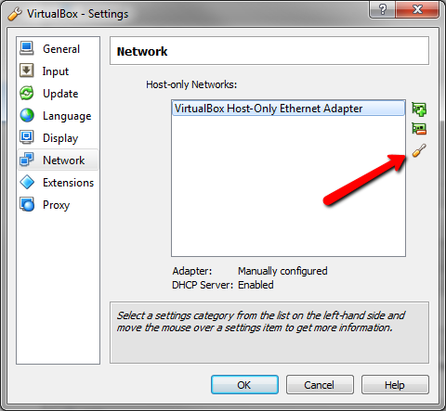

Replace default 192.168.56.1 with
10.154.137.1

