Creating a Free Trial Azure Subscription
- If you already have a Microsoft account that has not already been used to sign up for a free Azure trial subscription, you’re ready to get started. If not, don’t worry, just create a new Microsoft account at https://signup.live.com.
- After you’ve created a Microsoft account, browse to https://aka.ms/edx-DAT215.5-az and click the
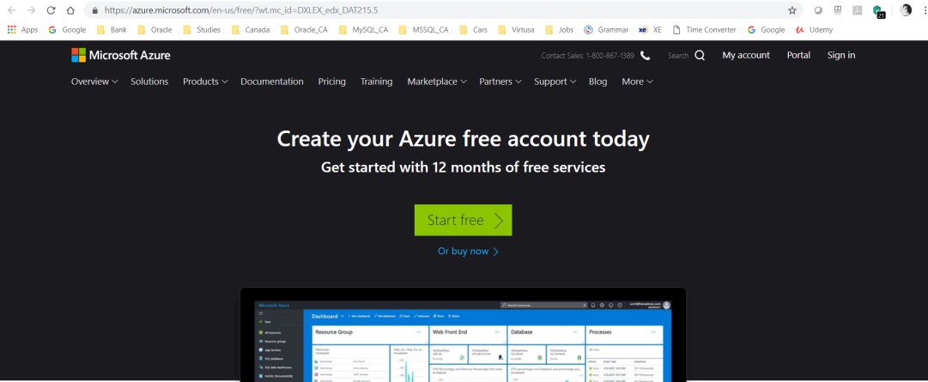
Free Trial link. Then follow the instructions to sign up for a free trial subscription to Microsoft Azure. You’ll need to sign-in with your Microsoft account if you’re not already signed in. Then you’ll need to:
  - Enter your cellphone number and have Microsoft send you a text message to verify your identity.
  - Enter the code you have been sent to verify it.
  - Provide valid payment details – don’t worry, your credit card won’t be charged for any services you use during the trial period, and the account is automatically deactivated at the end of the trial period unless you explicitly decide to keep it active.
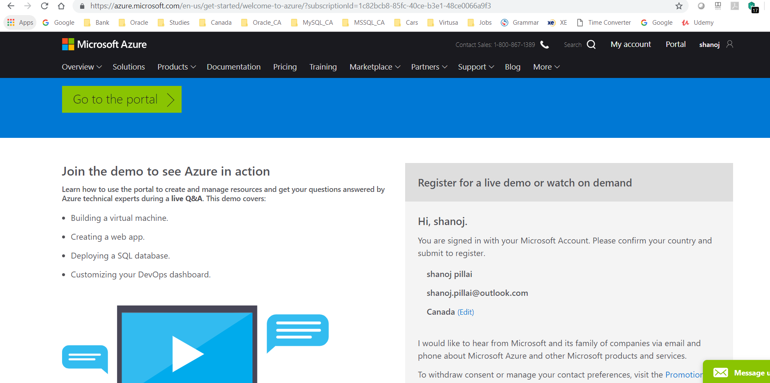

Create an Azure SQL Database
Now that you have an Azure subscription, you can create an Azure SQL Database instance to use in the labs.
- Browse to http://portal.azure.com. If you are prompted to sign in, do so with the Microsoft account that is associated with your Azure subscription.
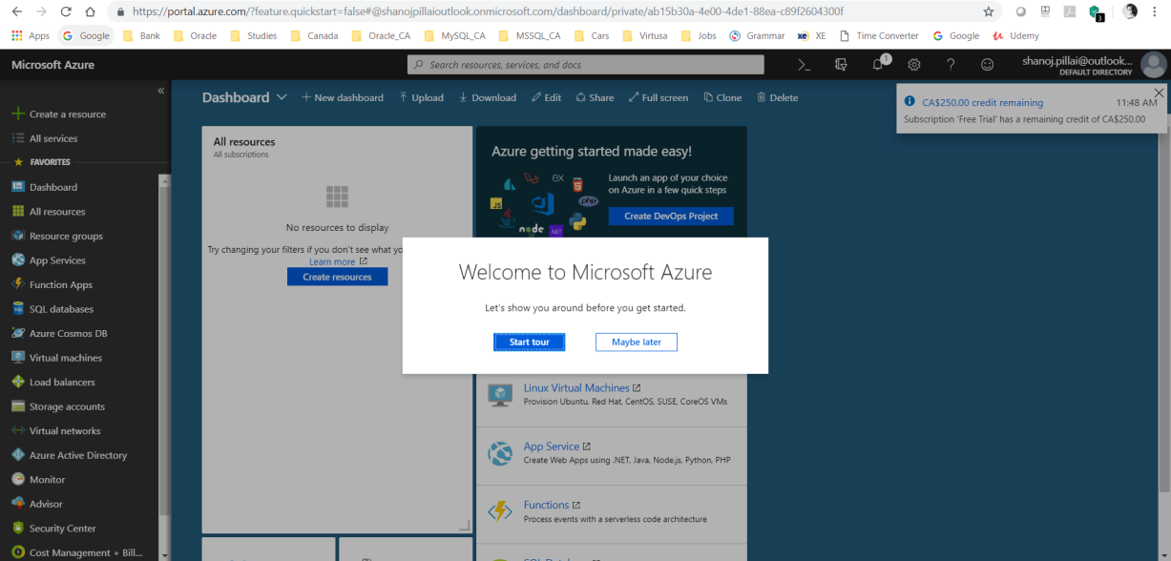
- At the bottom of the Hub menu (the vertical bar on the left), click New (represented by a  symbol if the menu is minimized), and then in the New blade that appears, click Databases, and then click SQL Database.
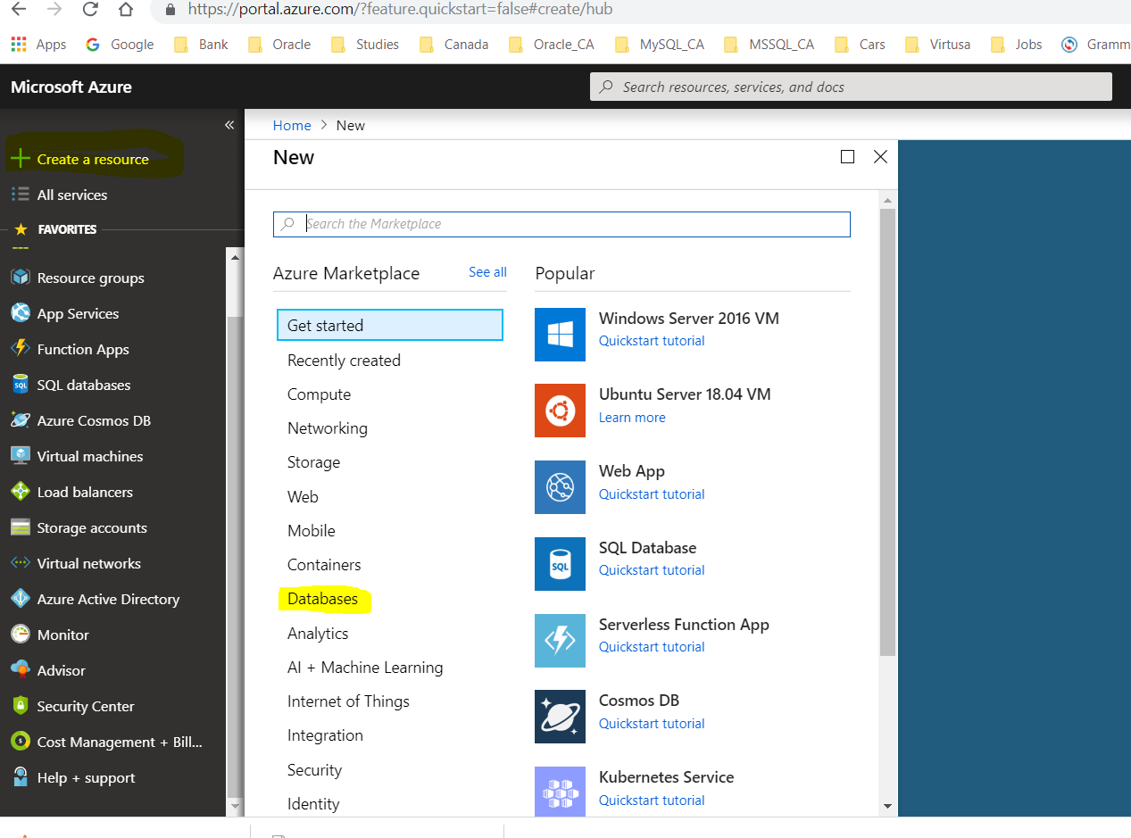

- In the SQL Database blade:
- Enter the name AdventureWorksLT
- In the Subscription box, ensure that your subscription is listed.
- In the Resource group section, ensure that New is selected, and enter sqlgroup as the new resource group name.
- In the Select Source list, select Sample.
- In the Select sample section, ensure that AdventureWorksLT[V12] is selected.
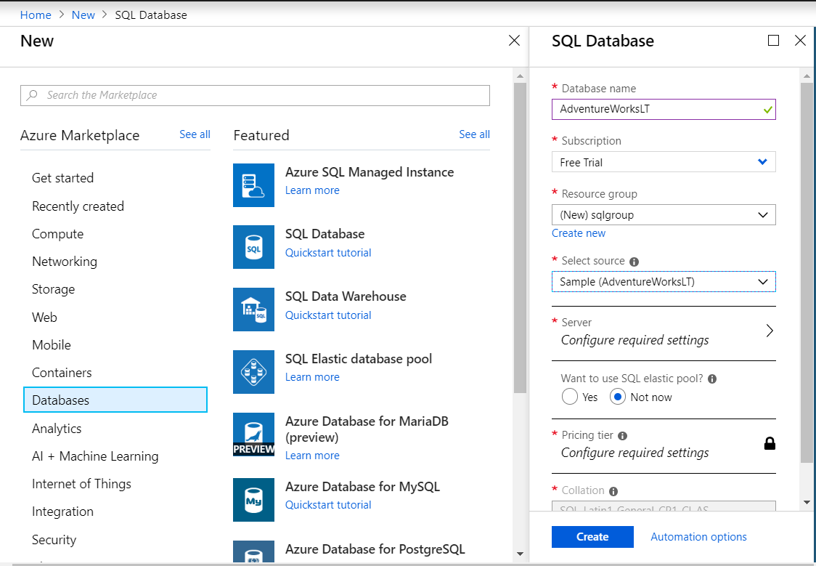
- Click Server. Then click Create a new server and enter the following details and click OK.
  - A unique Server name for your server (a pink exclamation mark will be displayed if the name you have entered is invalid or already in use, otherwise a green tick is shown)
  - A user name you want to assign to the Server admin login. This can be your name or some other name you’ll remember easily – however, you cannot use “Administrator”.
  - A Password for your server administrator account. This must meet the password complexity rules for Azure SQL database, so for example it cannot be blank or “password”.
  - The Location where your server should be hosted. Choose the location nearest to you.
Note: At the time of writing, the latest version of Azure SQL Database is V12. If this version is available in your regions, select it.
  - Leave the option to allow Azure services to access the server selected (this opens an internal firewall port in the Azure datacenter to allow other Azure services to use the database).
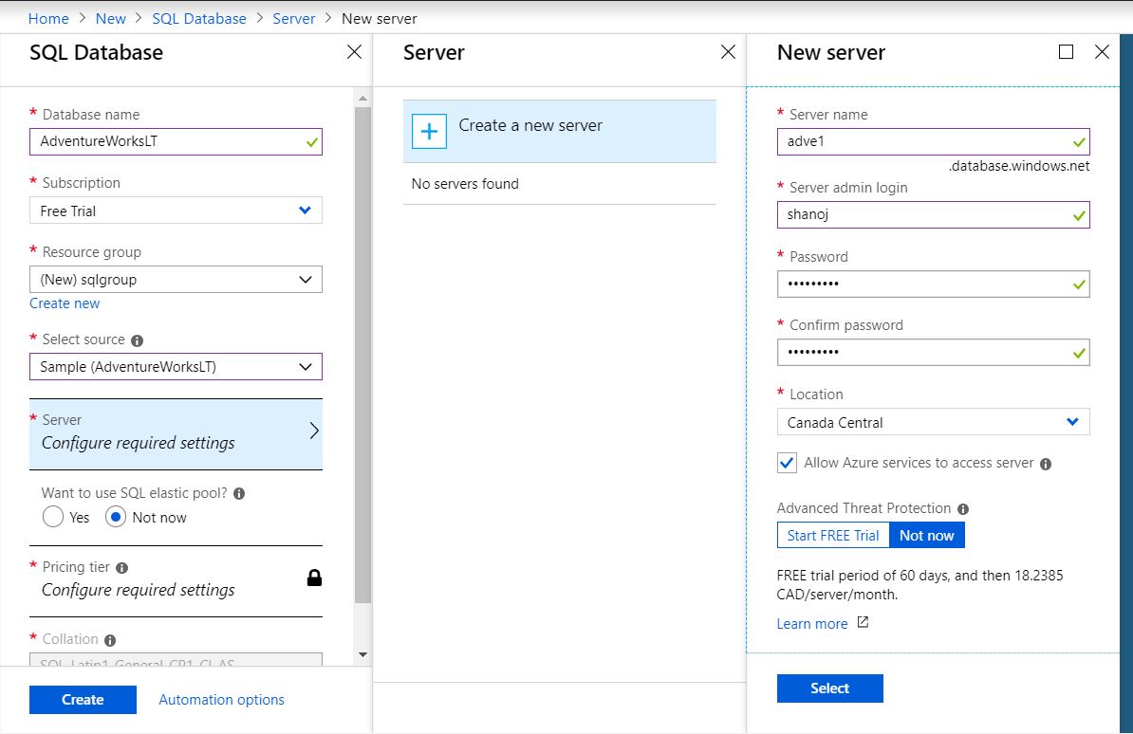
- In the Pricing Tier section, select Basic.
- Ensure that your selections are similar to those below, and click Create.
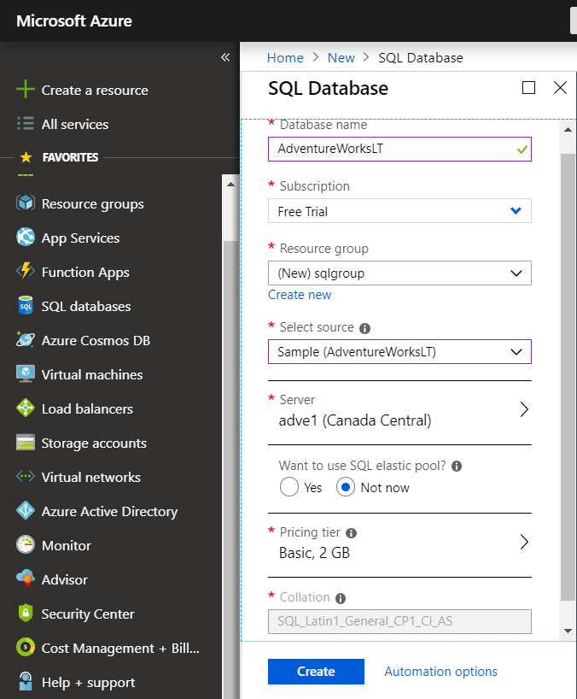
- After a short time, your SQL Database will be created, and a notification is displayed on the dashboard.
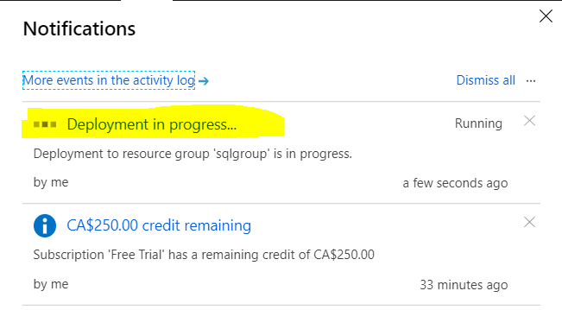
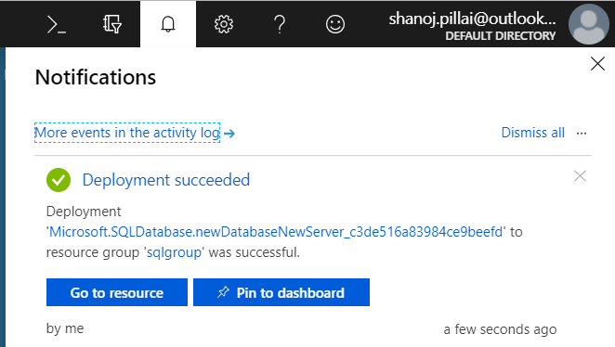

- To view the blade for the database, click All Resources, and then click the AdventureWorksLT database.

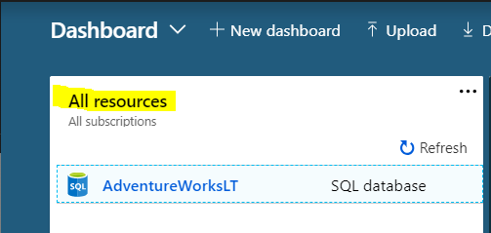

Configure Firewall Rules for your Azure SQL Database Server
- In the AdventureWorksLT blade, under Essentials, click the server name for your database server (which should be in the format server_name.database.windows.net).
- In the blade for your SQL server, under Essentials, click Show firewall settings.
- In the Firewall settings blade, click the Add client IP icon to create a firewall rule for your client computer, and then click Save.
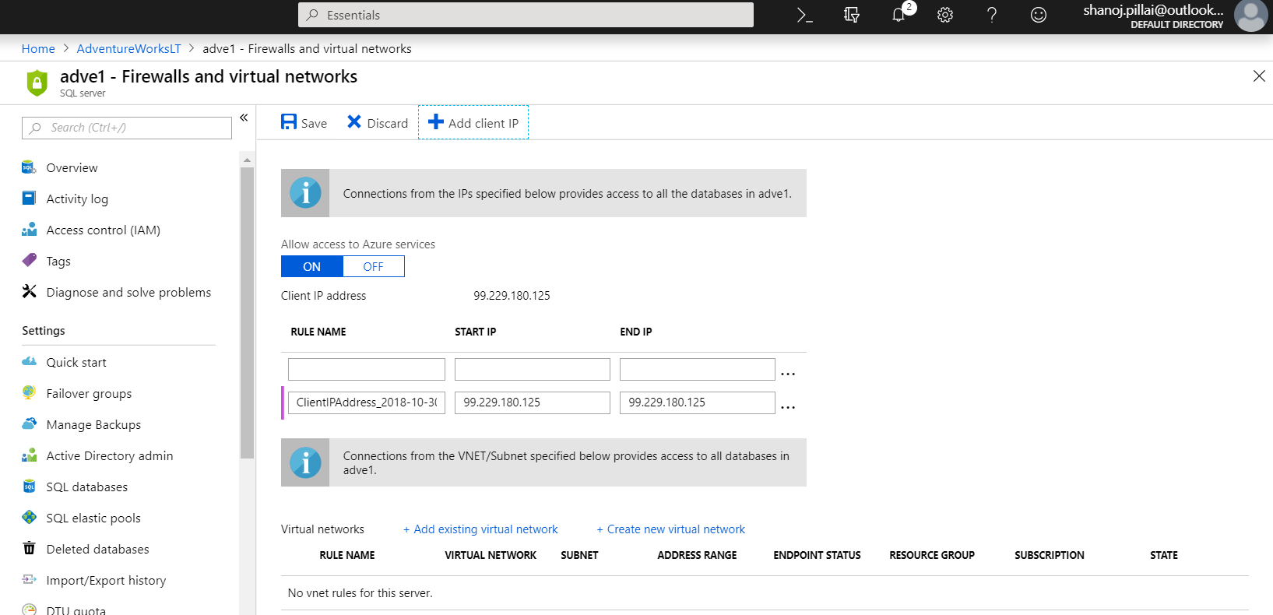

Note: Azure SQL Database uses firewall rules to control access to your database. If your computer’s public-facing IP address changes (or you want to use a different computer), you’ll need to repeat this step to allow access. Alternatively, you can modify the firewall settings for your Azure SQL Database server to allow a range of IP addresses – see the Azure SQL Database documentation for details of how to do this.

Installing and Connecting from a Client Tool
You can use either of the following tools to develop your Transact-SQL queries.
Note: These tools are designed for Microsoft Windows. If you are using a non-Windows computer, you can install a third-party SQL Server client application for your platform. See the notes at the end of this document for more details.

Microsoft SQL Server Management Studio
SQL Server Management Studio is the primary management tool for Microsoft SQL Server, and you can also use it to manage and query Azure SQL Database. If you do not already have SQL Server Management Studio installed, you can download it from https://aka.ms/edx-DAT215.5-ssms.
When the download is complete, run the executable file to extract the installation files to a folder on your computer and start the setup wizard, then use the SQL Server installation center to perform a new standalone installation of SQL server and install only the management tools.
After installing SQL Server Management Studio, you can start it and connect to your Azure SQL Database server by selecting the option to use SQL Server authentication, specifying the fully-qualified name of your Azure SQL Database server (<your_server_name>.database.windows.net), and entering your user name in the format <your_user_name>@<your_server_name> and password, as shown here:
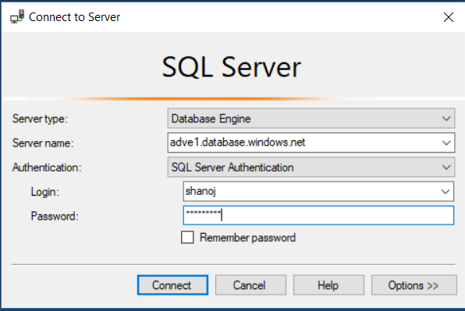
After connecting, you can create a new query and run it by clicking Execute, and you can save and open Transact-SQL scripts. Be sure to select the AdventureWorksLT database when running your queries as shown here:

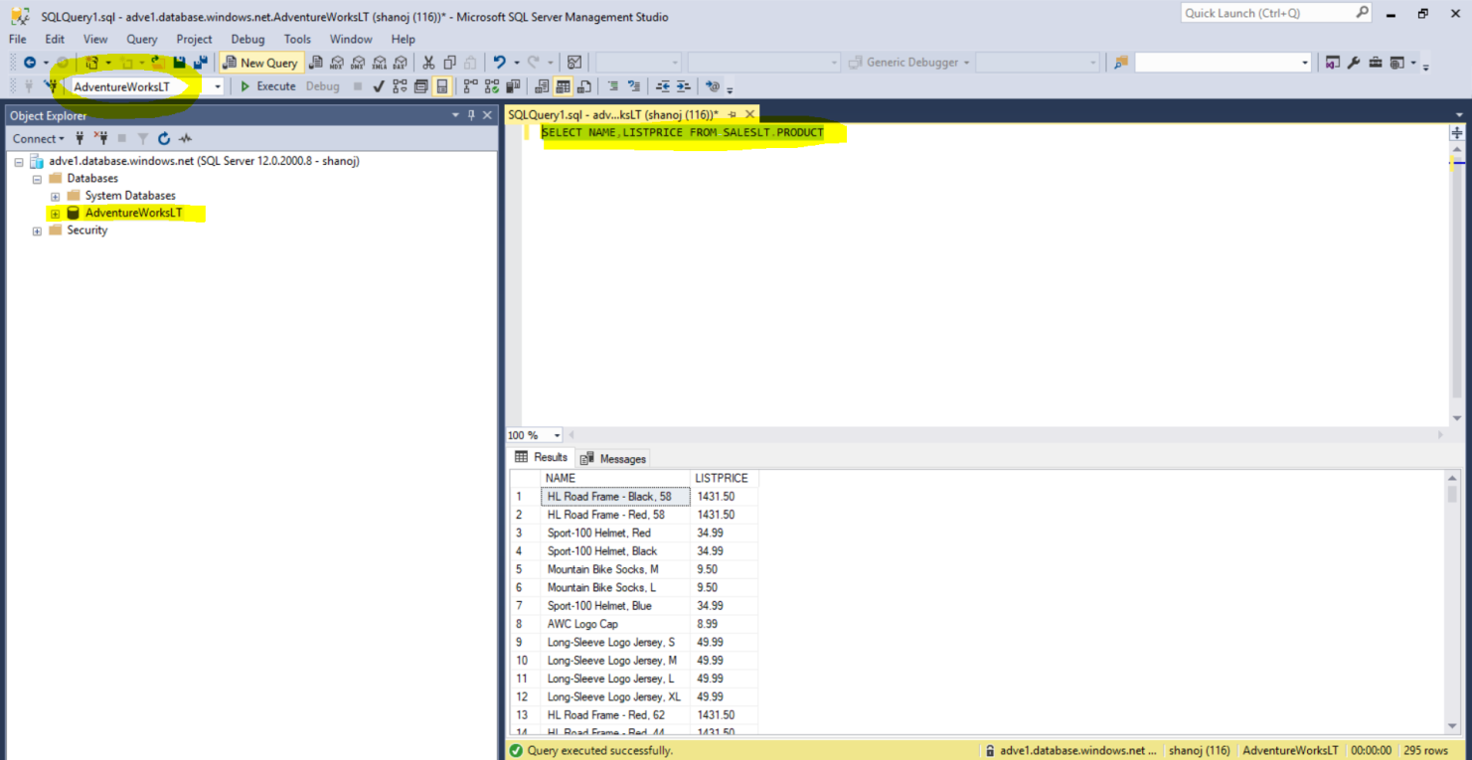

SELECT NAME,LISTPRICE FROM SALESLT.PRODUCT

Microsoft Visual Studio
If you are primarily a developer, you may prefer to use Visual Studio to create your Transact-SQL queries. Visual Studio is a comprehensive software development environment for all kinds of software projects, including database development. You can download the free Community edition of Visual Studio from http://aka.ms/edx-DAT215.5-vs and install it on your Windows computer.
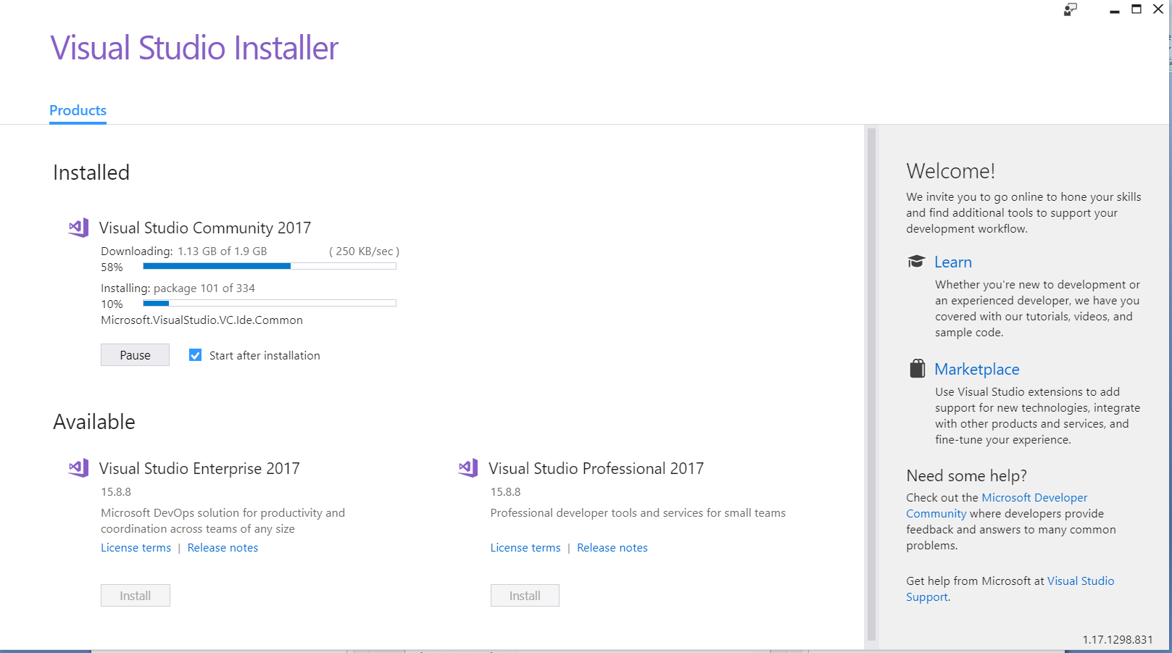

When you install Visual Studio, be sure to select the option to include the SQL Server Data Tools optional component. Then, in the Server Explorer pane, you can create a data connection to your Azure SQL database server using the Microsoft SQL Server (SqlClient) data source as shown here.
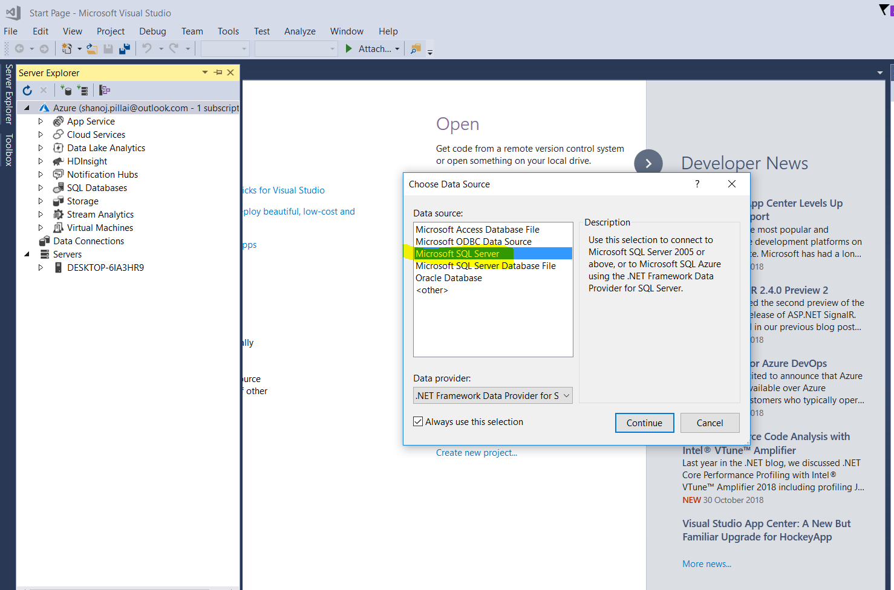

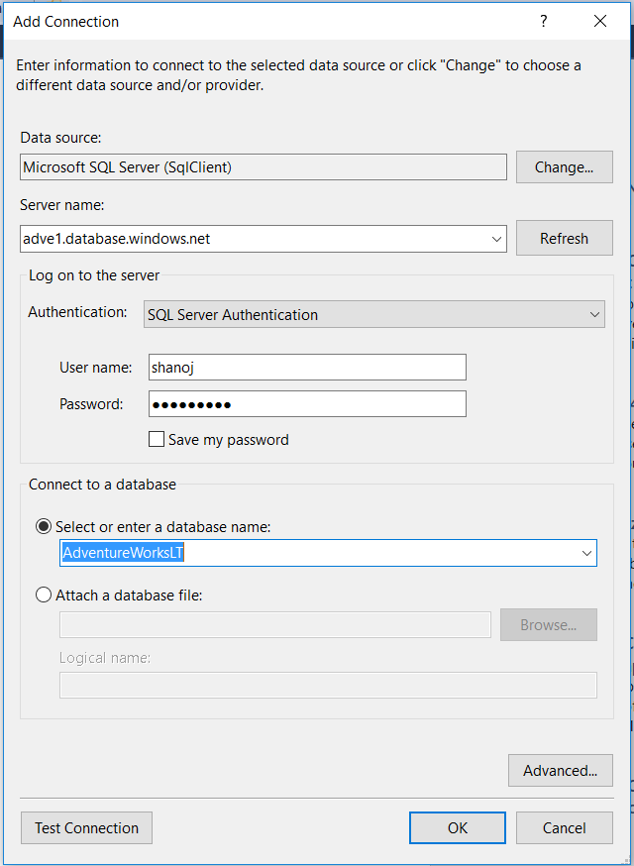

After you have created a data connection, you can view database objects in the Server Explorer window.
You can also create and save Transact-SQL scripts and run queries, as shown here.
